019 TypeScript - array.sort method

TypeScript Kata List – Blog Page

[TypeScript Kata List on GitHub](https://github.com/robertdunaway/katas-typescript)

# Duration

10 minutes

# Brief

[subject of kata]

### For More Information

BING/GOOGLE: “TypeScript array sort”

# Instructions

Get tutorial folder or the entire katas-typescript repo.

Open the [before/*.sln] file and execute the kata.

Feel free to execute this kata multiple times because repetition creates motor memory.

# Github

* Before (start kata with this)
  + https://github.com/robertdunaway/katas-typescript/tree/master/019%20TypeScript%20-%20array.sort%20method/before
* After
  + https://github.com/robertdunaway/katas-typescript/tree/master/019%20TypeScript%20-%20array.sort%20method/after

# Kata

Create a simple interface.

interface pet {

name: string;

age: number;

weight: number;

}

Popular a new array based on the new interface.

var myPets: pet[] = [

{ name: 'Sally', age: 18, weight: 85 },

{ name: 'Jasmine', age: 9, weight: 55 },

{ name: 'Rush', age: 15, weight: 45 },

{ name: 'Roxie', age: 6, weight: 85 }

];

Create a comparer based on age.

var compareAge = function (a: pet, b: pet) {

if (a.age > b.age) { return -1; }

if (a.age < b.age) {return 1; }

return 0;

}

Output the sorted array to the console.

console.log(myPets.sort(compareAge));

Create a comparer based on weight.

var compareWeight = function (a: pet, b: pet) {

if (a.weight > b.weight) { return -1; }

if (a.weight < b.weight) { return 1; }

return 0;

}

Output the sorted array to the console.

console.log(myPets.sort(compareWeight));

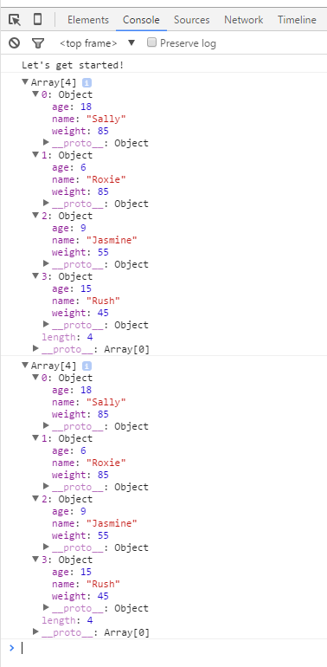

# Next

Take a few minutes and imagine more examples.